03-06-2025

Mekapothula Durga Venkateswara Reddy (22BCB7296)

1.inital id :1 in products collection

2.updating price

3.updated id:1

4.updating specific index on an array

5.updating inner JSON

6.update many types

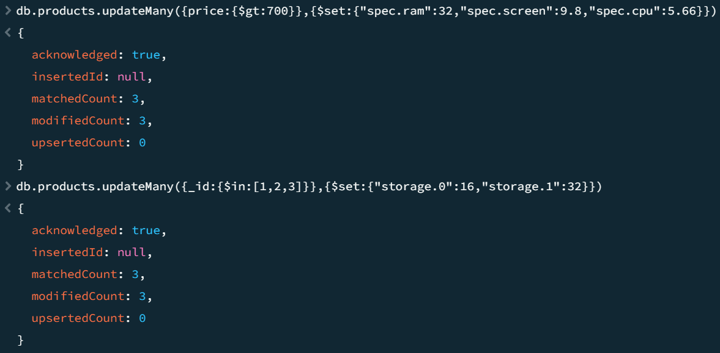

7.increment operator (updateOne)

8.negative increment (updateOne)

9.using updateOne updating(incrementing) multiple fields in single document

10. using updateMany updating(incrementing) multiple fields in multiple documents

11.$min (updates all price greater than 699 to 699)

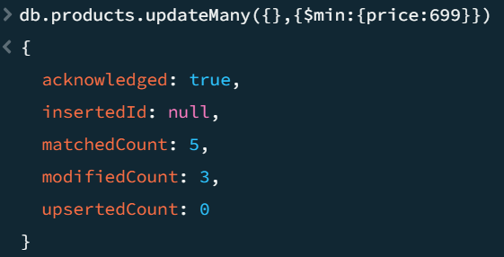

12.$max (updates all price less than 699 to 699)

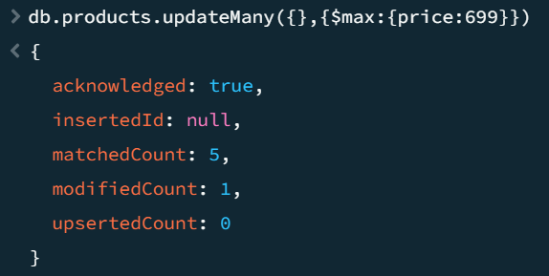

13.$mul (updating by multiplying)

14.$unset

Price field will be deleted entirely for id:1 document

15.but using $set and setting price value empty

Price field is not deleted but made empty

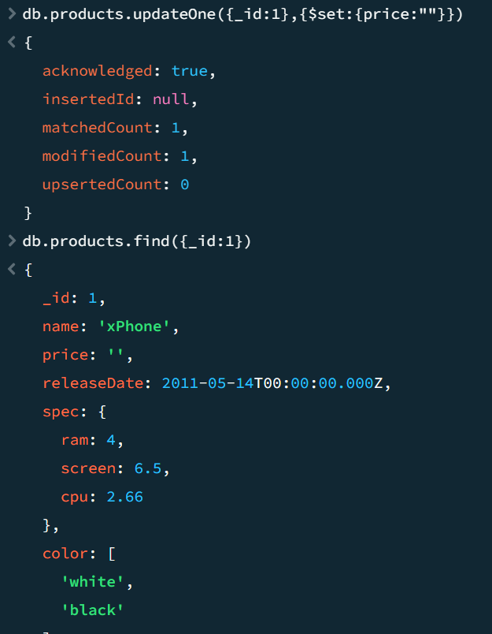

16. by $set setting price to null will display null in price field

17.unsetting ram in spec

Output: ram filed is entirely deleted in every document.

18.upadting field name by $rename

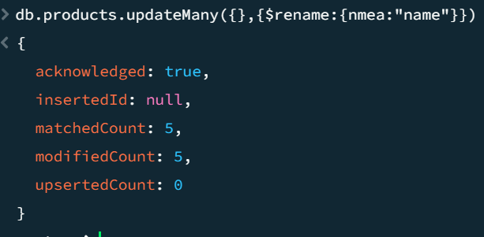

nmea to name

19.”spec.cpu” to “cpu” using $rename bringing out cpu from spec as a separate JSON

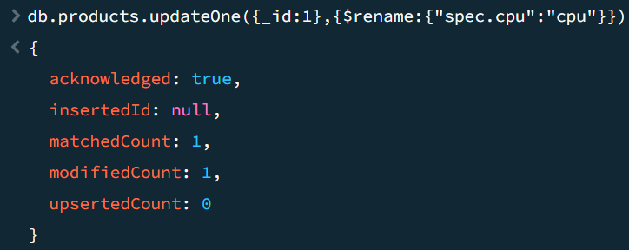

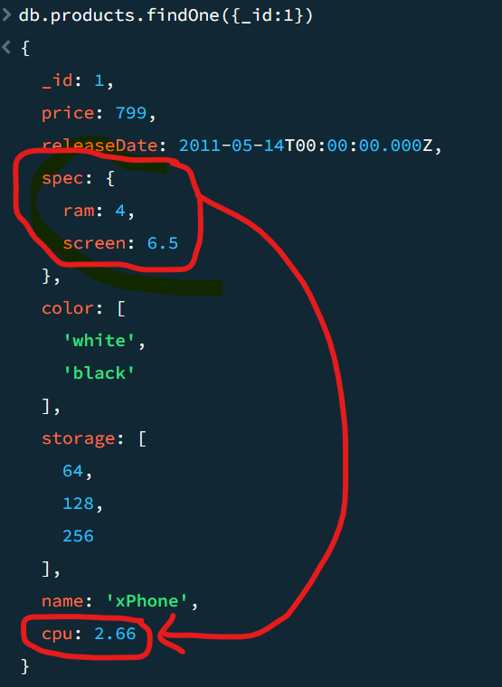

20. renaming a field with already existing filed name

Here storage field is entirely deleted and color field is renamed to storage.

21.$upsurt



